

**System Analysis and Design**

# **Traffic Safety Mobile Application**

**Correct Version of Task 1 Diagrams**

1. **Use Case Diagram**

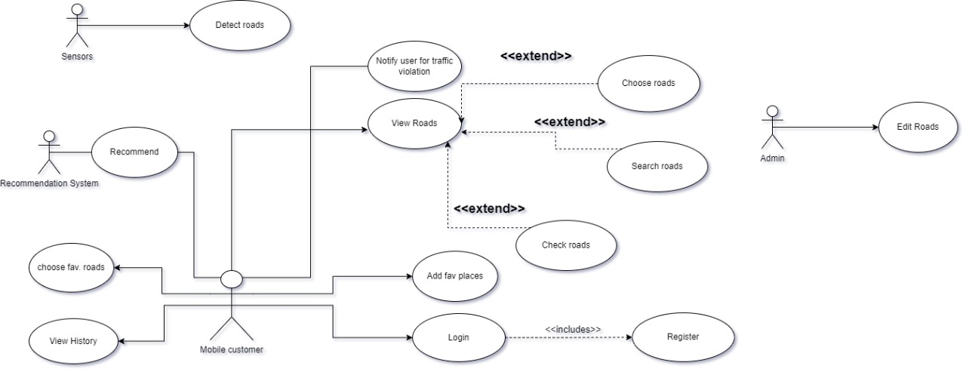

1. **DFD Diagrams**
   1. **Context Diagram**

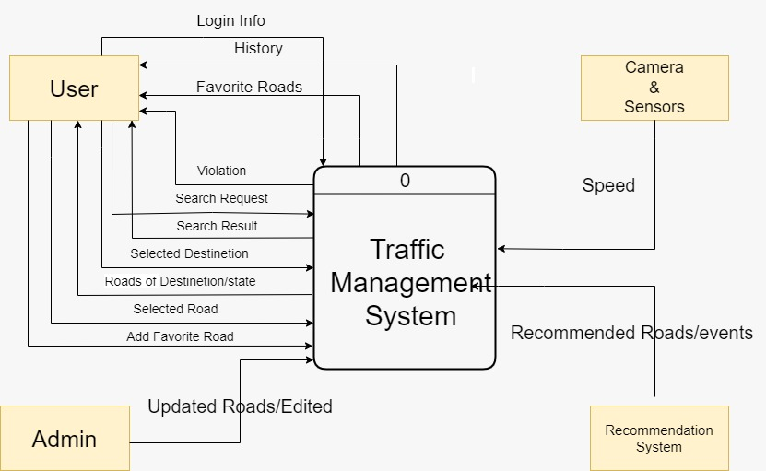

* 1. **Level 0 Diagram**

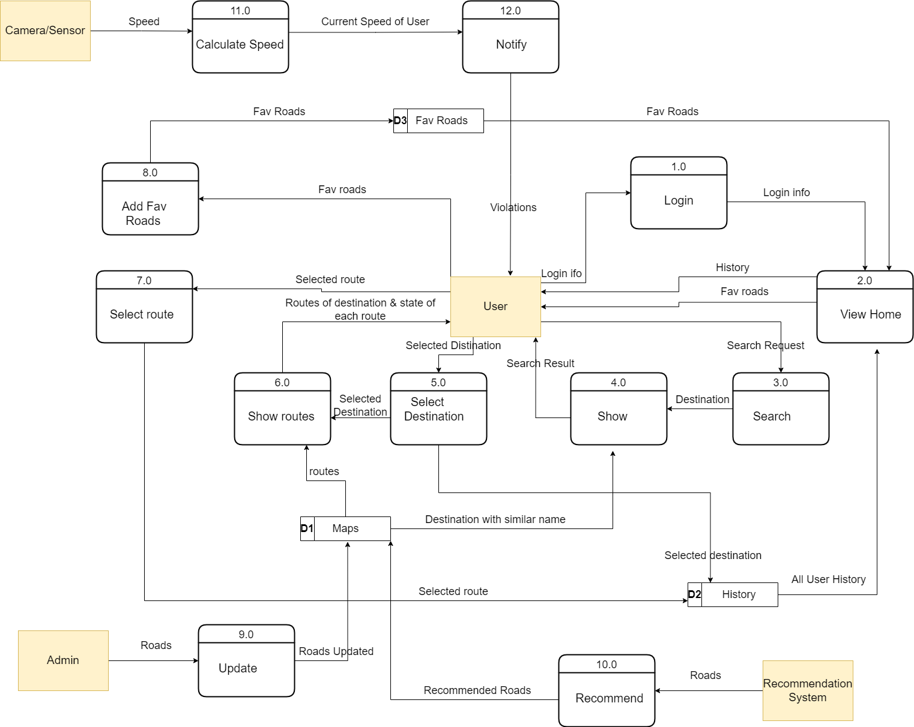

* 1. **Level 1 Diagram**

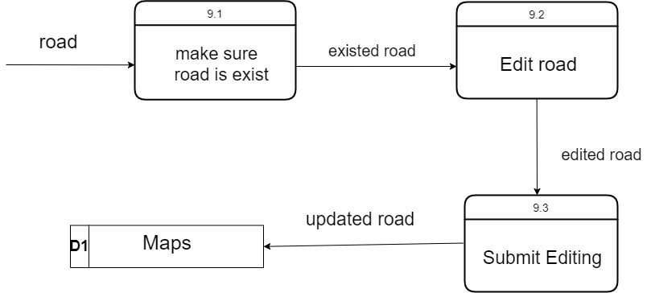

**Task 2**

1. **Class Diagram**

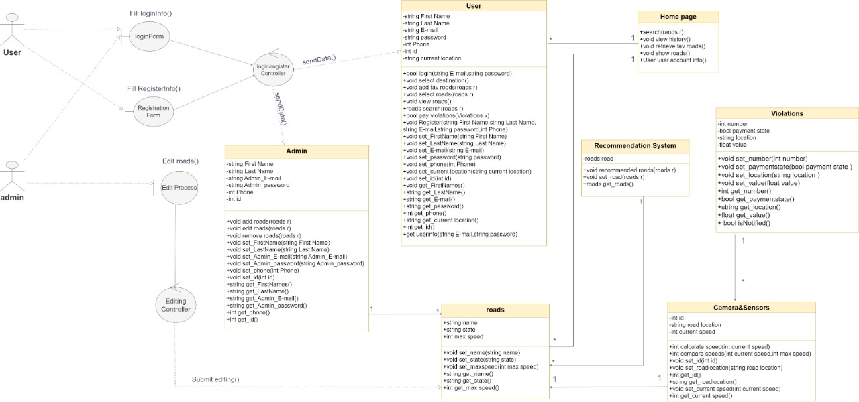

**2.Sequence Diagrams**

